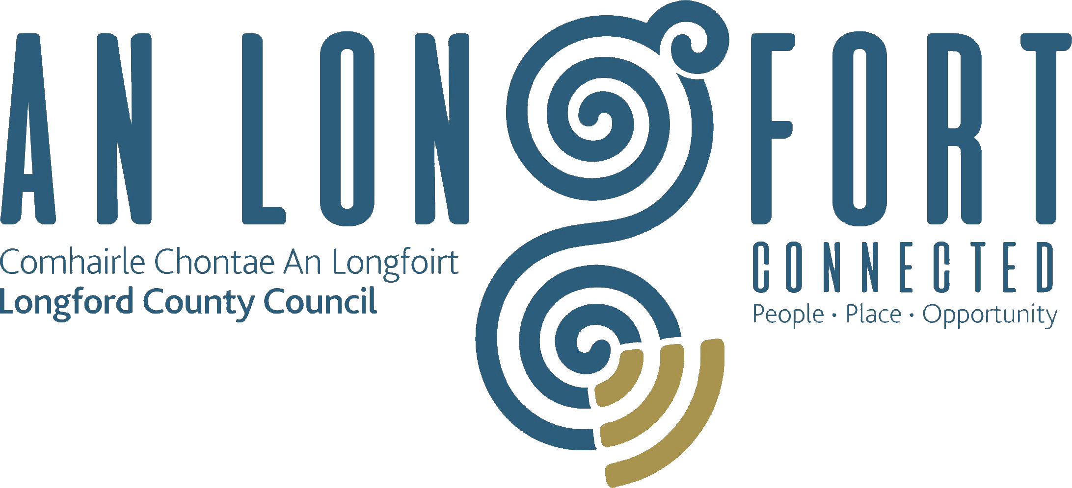

Minutes of Special Meeting of Longford County Council
held in the Council Chamber, Aras an Chontae, Great Water Street, Longford on
Wednesday, 9th January 2019 at 4.00 p.m.
____________________________________________________________________

PRESIDING: Councillor Luie McEntire, Cathaoirleach.

MEMBERS PRESENT: Councillors – Paraic Brady, John Browne, Seamus Butler, Mick Cahill, Micheál Carrigy, Mark Casey, Gerard Farrell,
Joe Flaherty, Gerard Hagan, Colm Murray, Peggy Nolan, Pat O’Toole, P.J. Reilly, Paul Ross, Mae Sexton and Gerry Warnock.

IN ATTENDANCE: Mr. John McKeon, Deputy Chief Executive.
Ms. Barbara Heslin, Director of Services.
Mr. Donal Mac An Bheatha, Senior Planner.
Ms. Louise Kiernan, Executive Planner.
Mr. Terry Rooney, Senior Executive Officer.

Mr. Jim Conway, Eastern & Midland Regional Assembly.
Mr. Malachy Bradley, EMRA.
Minister Kevin Moran.
Deputy Robert Troy.
Councillor Padraig Fleming, Laois County Council.
Councillor Una Darcy, Westmeath County Council.
Councillor Tom Farrell, Westmeath County Council.
Councillor John Dolan, Westmeath County Council.

APOLOGIES: Councillors Gerard Farrell and Martin Mulleady
Mr. Paddy Mahon, Chief Executive.
Minister Charlie Flanagan.

MEETINGS
ADMINISTRATOR: Ms. Anne Lee.

DRAFT REGIONAL SPATIAL AND ECONOMIC STRATEGY.

Malachy Bradley gave a comprehensive presentation to the members on the Draft Regional Spatial and Economic Strategy-

The Draft RSES is a strategic plan which identifies regional assets, opportunities and pressures and provides appropriate policy responses in the form of Regional Policy Objectives. At this strategic level it provides a framework for investment to better manage spatial planning and economic development throughout the Region.

Malachy stated that the Draft RSES provides a:
- Spatial Strategy – to manage future growth and ensure the creation of healthy and attractive places to live, work, study, visit and invest in.
- Economic Strategy – that builds on our strengths to sustain a strong economy and support the creation of quality jobs that ensure a good living standard for all.
- Metropolitan Plan – to ensure a supply of strategic development areas for the sustainable growth and continued success and competitiveness of the Dublin metropolitan area.
- Investment Framework – to prioritise the delivery of key enabling infrastructure and services by government and state agencies.
- Climate Action Strategy – to accelerate climate action, ensure a clean and healthy environment and to promote sustainable transport and strategic green infrastructure.

The issues wre raised by the members present included:–

Term 'Outer'
- Concern that this could be seen as demoting the importance of the Midland Counties

Population
- Need more flexibility on population numbers - 25% headroom suggested
- Cannot be a restrictor on sustainable economic development or provision of affordable housing
- Industry already facing challenges filling job vacancies due to a lack of suitable housing

Rural Ireland
- Concern that RSES could negatively impact on rural communities
- Definition of rural versus small towns and villages in the Settlement Strategy demoted towns like Granard to rural village status, ignoring its functional area, the significant employers serving national and international markets and the assets in the town (including recreational, sports, cultural and heritage).

Connectivity
- Importance of including N55 as a strategic road reflecting its importance as a north south interconnector and route to Center Parcs and Athlone
- Upgrade of N4 between Mullingar and Leitrim border should be prioritised in the list of projects
- Upgrading of Sligo to Dublin rail line to dual rail should be included in the rail projects
- Broadband and telecommunications investment - major issue for Longford (slowest broadband and highest number of blackspots in the Country)

Regional
- Longford has an important role to play in supporting the development of Athlone as a Strategic Growth Centre
- A more positive story for each of the key towns in the Region needs to be incorporated
- A long term strategy for the Midlands, recognising the Regional Strategic Objectives of the Midland Regional Enterprise Plan and the important role of Athlone as an economic driver and growth centre of the region, should be developed.
- Redesignate Athlone IT as a University

Opportunities
- Brownfield sites - economic and housing development
- Peatlands - tourism, activities, research, education
- Build on existing business clusters
- Diverse communities - language and skills
- Assisting in the Bord na Mona transition from peat to biomass
- Renewable energy and provision of biomass
- Expand the opportunities to become the 'food basket' for the region
- Tourism infrastructure - Greenways and Blueways
- Grand Canal link to Royal Canal Greenway along the Shannon

Malachy and Jim thanked the members for their engagement and observations and confirmed that the closing dated for receipt of submissions remains at 23rd January. They also referred to AILG seminar in the Mullingar Park Hotel on the 19th January where the Regional Directors and their staffs will also brief Councillors on the highlights of the Draft Plan while listening to opinions from elected members based on the planning needs of their local authorities within each region.

It was agreed that the Council's formal submission on the RSES will include a detailed list of the issues raised - see attached Appendix.

This concluded the business of the meeting.
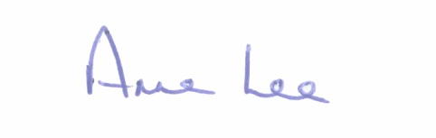

Signed: _______________
Anne Lee,
Meetings Administrator.

Confirmed and adopted at Monthly Meeting of Longford County Council held on the
13th February 2019.

Signed: _______________
Cathaoirleach.

Appendix

- Infrastructure
- Prioritise in RSES the upgrading of N4/M4 (Mullingar to Leitrim border) and N55 (north south corridor)
- Rail Line - dual rail
- Recognise importance of N5 - connectivity to North West and Knock Airport
- Knock Airport - important for regional development
- Irish Water - concern that without their support and investment sustainable development may not be possible. Capacity issues will curtail expansion in housing and industry.
- Longford badly served by previous plans
- Pressure to provide dense housing resulted in unfinished estates
- Population and head room (25%) needs to reflect the historic increased and the impact of the job announcements (excess of 1,000)
- Affordable housing required in order to facilitate recruitment and retention of employees
- Impact on business decisions and ability of businesses to fill job vacancies
- Longford's ambition for community and economic development cannot be restricted because of population caps
- Factors influencing companies to invest, expand - access to qualified people, housing, social
- Impact of lack of housing on companies like Abbott
- RSES too Dublin centric
- Each county should be afforded their own opportunities to develop
- Concern that a project such as Center Parcs would not have been possible in Longford if the draft RSES was in place
- Athlone is the strongest link for Longford and this needs to be expanded upon in the RSES
- Flexibility required to provide opportunities to avail of national and EU funding
- N55 - North South artery and important link to Center Parcs
- Rural Areas versus Small Towns and Villages - definition
- Granard -example of town population versus functional area
- National businesses / job opportunities
- Quality of Life - Natural Assets
- Lakes, bogs, woodlands, rivers - opportunities including tourism and activities such as angling, fishing, walking and cycling
- Opportunities to address climate change
- Trails already developed
- Working with national bodies and agencies e.g. BnM, WI, IFI, Coillte
- Disability access - Age friendly
- Key attractor for people looking to relocate
- Outer Region - rename Midlands Region
- Longford suffered under the previous NSS - negative economic implications for the town and County
- RSES is an opportunity to address deficit in investment and rebalance economic development
- Regional perspective and connectivity - links to other regions, especially Northern and Western Region
- Strategic portal to North West
- Midlands region supports Athlone development
- Tourism objectives should recognise Ireland's Hidden Heartlands
- Higher provide required for tourism - very few RPOs
- Tourism - Mid Shannon, Greenways, Blueways, peatways, Corlea - opportunities and priorities
- Highlight opportunities to extend the Greenways to Mayo and Sligo
- Center Parcs - regional, national and international tourism offer
- Broadband and telecommunications - importance to rural counties such as Longford - impact on quality of life, education and enterprise
- Digital Hubs - opportunity to address deficit in broadband provision
- Libraries - including Open Library initiative
- Need fast access to and from Dublin and Sligo
- Railway line - dual track - investment and upgrade required
- N55 connectivity to Athlone, M6 and M7
- County Longford more aligned to West of Ireland
- Economic opportunities and strategies for Longford need to be expanded
- Definition of rural areas, small towns and villages need to be looked at in the context of functional areas and asset tests
- Reverse commuting - Midlands Region issue - bring jobs to where the people live
- Rural economies reflected in the draft but there is concern that lands may have to be dezoned, impacting on future economic development
- Need services sites in order to attract new enterprises
- Data centres and back office services - opportunities for rural counties such as Longford
- Agriculture - need to increase profile and include objectives e.g. biomass, food basket
- Opportunities provided by cutaway bogs
- Gas - vision is to see extension to Edgeworthstown, Longford town and Granard
- Quality of Life - Arts, Cultural and Heritage
- Longford support of communities through the provision of investment for the Mall, car parking, Backstage, etc
- Need to support people who want to move back to the country
- Wealth of talent
- Support heritage led regeneration
- Festivals - range increasing and improving
- Role of Arts Council in promoting and supporting smaller theatres, arts facilities and festivals
- Revision of the definition of rural area and small towns and villages
- Rural communities - challenges faced with closure or post offices, banking facilities, small shops and pubs
- Rural housing - RSES should not restrict or place unreasonable barriers on one off housing
- Flexibility in RSES to allow sustainable development in rural areas
- Quality of Life - Education and Young People
- Links with Sligo IT, Athlone IT, Maynooth, Galway, Dublin
- Need more links between business and third level colleges - prepare students for the real world
- Connectivity essential - road, rail, broadband and telecommunications
- Need opportunities to attract young people back to rural Ireland
- ETB
- Sports
- Disability Training
- Apprenticeships
- Quality of Life -Healthcare
- Diversity / Integration / Opportunities
- Flexibility in RSES to allow sustainable CDP
- Need to recognise that face of retail is changing - example Riverside Shopping Centre - experiential and entertainment focus
- Longford town profile and objectives - need to be enhanced and strengthening
- Recognise opportunities to build on business serving national and international markets
- Retail Strategy - consider leaving to County Development Plans
- Retail Strategy (if retained) - Longford and Granard included but need to include Ballymahon, Edgeworthstown and Lanesboro
- Need to be more ambitious for Midlands Region
- Dublin under pressure
- Population growth needs to be more ambitious
- Expansion by companies - where will people live
- Building on family farms - restrictions will impact on communities

